Type0, Type-1 and Type-2.  
Create Source and Target tables in database.

Type0:

2.Type1

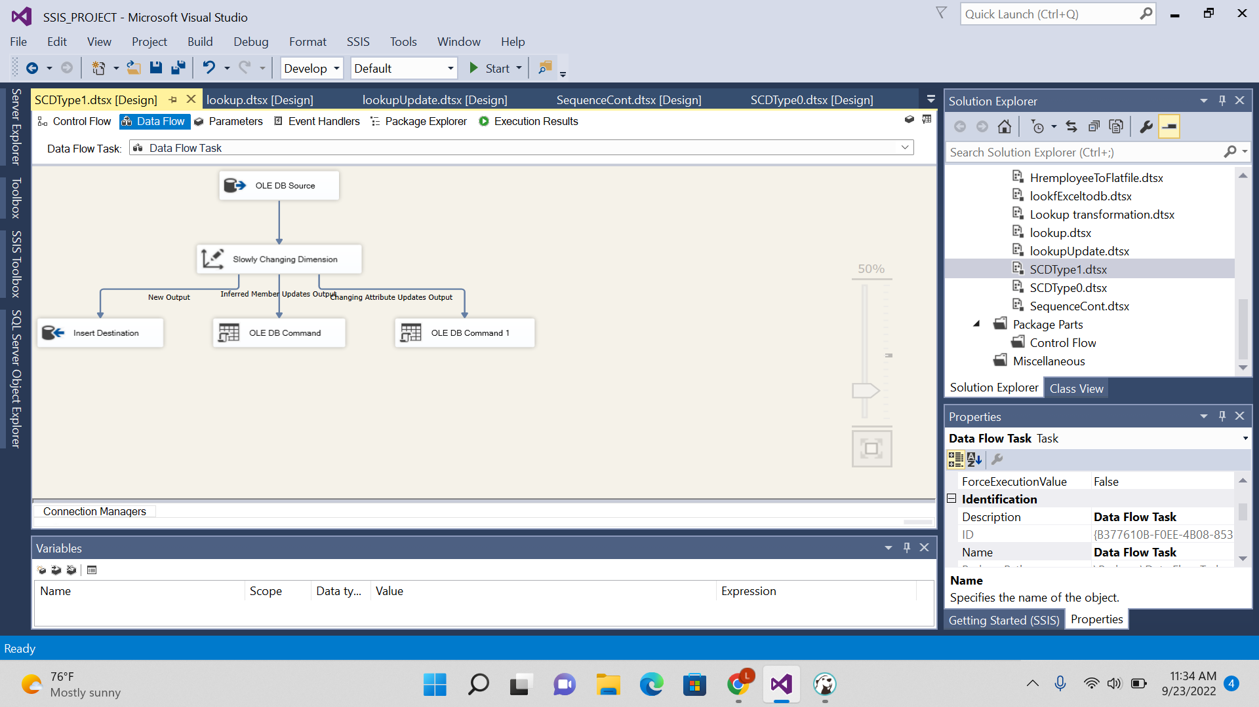

3. Type2

